A connectome-constrained Drosophila neural network learns to act as a Maxwell demon in a simulated particle system
Abstract:
Keyword:
Experiment:
Introduction
Experiment results (Fly brain Fly test as maxwell demon):
Can a biologically constrained neural network control a physical simulation in a way that produces Maxwell-demon-like behaviour, and can that behaviour be learned?
-Fly outcome
Why fly retursn to its position form demon why it keep trying to replace demon?
-In all experiments Fly position locomotion
-Fly data what’s used? Ref in methods
-How was simulation developed? the big picture basic outline of the structure
-How its working simulation standard
Data: Video recording of changes on different condition firing Synaptics; data logged
What AI was used to make learn brain fly this ?
How it learned What was the approach ?
Why it diidnt hsowed ?

Conclusion

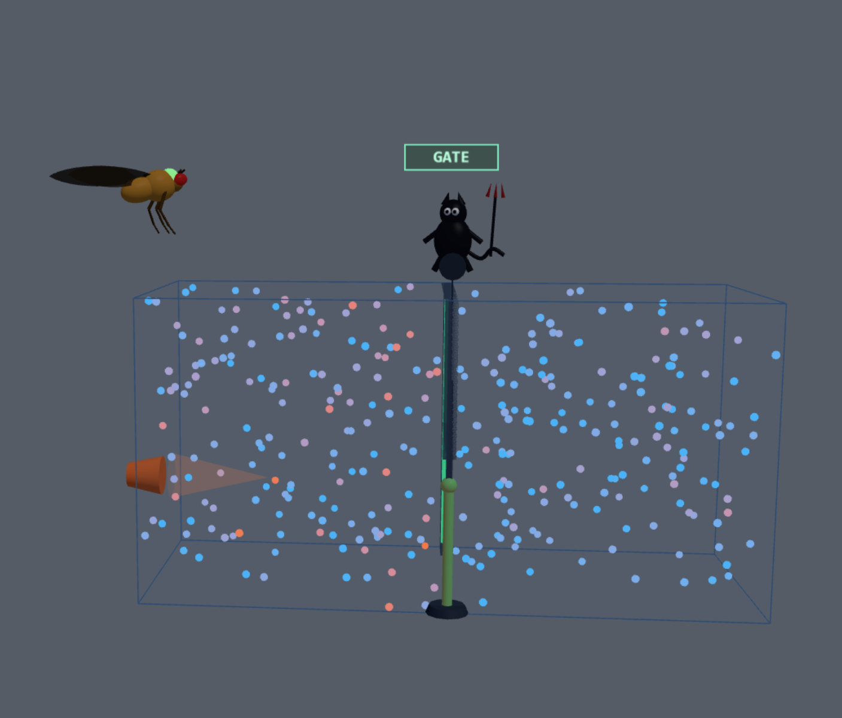  Energy parameter equilibrium, Maxwell demon action, Fly action | 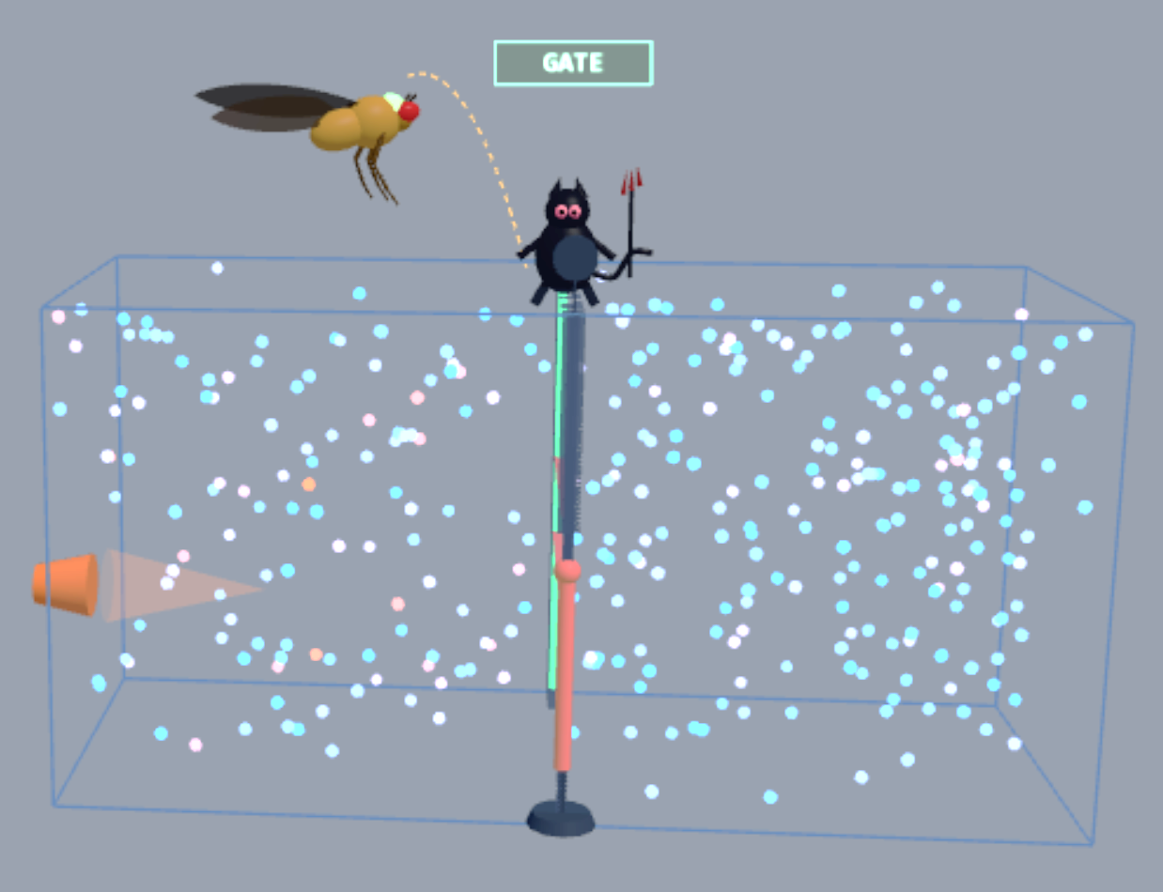  Energy parameter equilibrium, Maxwell demon action; fly action
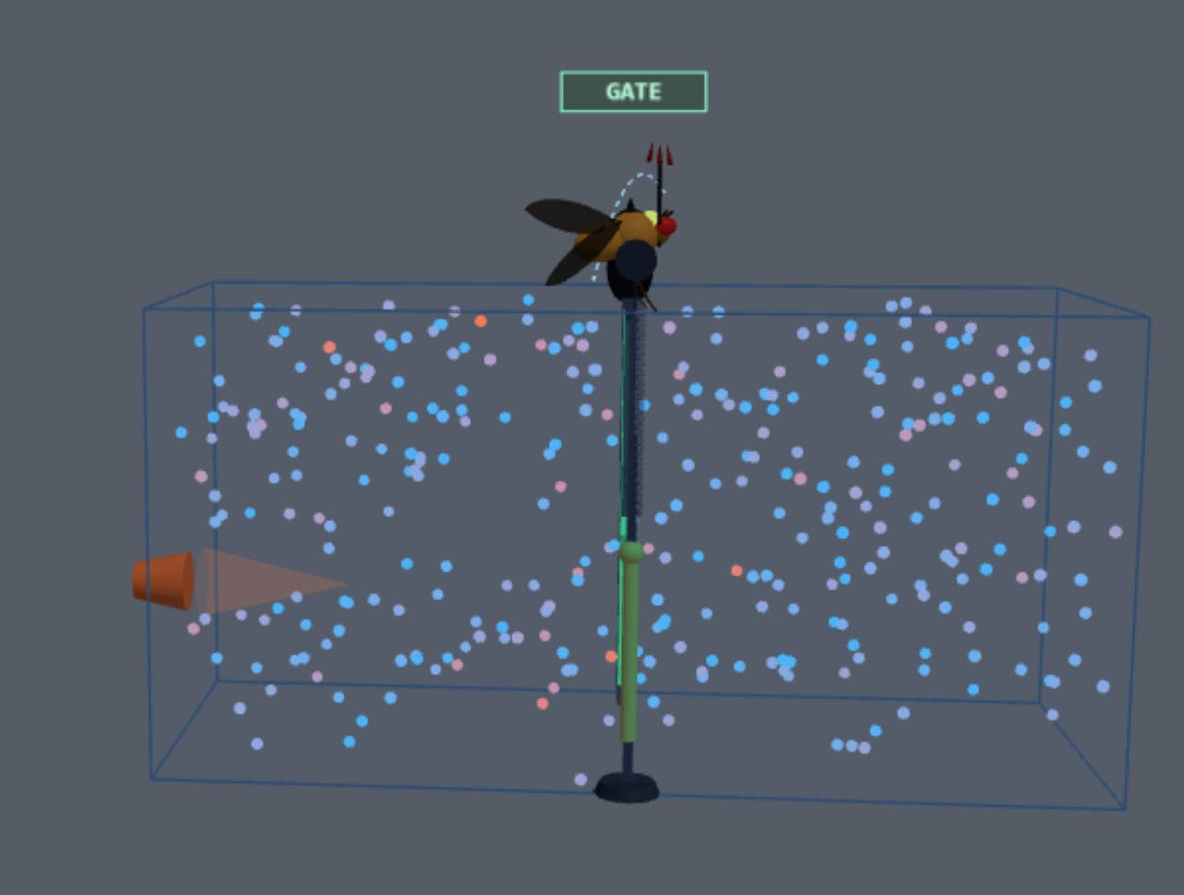  Energy parameter Equilibrium, Maxwell demon action, Fly action | 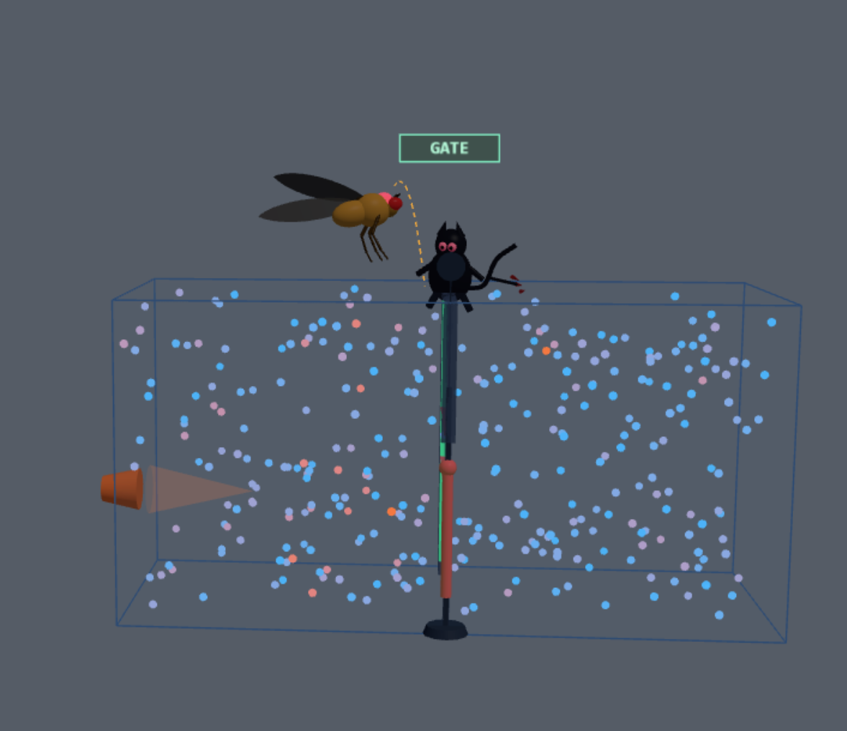  Energy parameter Equilibrium, Maxwell demon action, Fly action

Explain the apparatus what is what and annoatateeach single strutre and explain Maxwell demon condiotn
Run the test of Lab adjust all the value and collect the data to underadtn how
These condiotn : Demon driver
🧠 Fly brain🎲 Random🧑 You
learning rate0.004
dopamine scale1.5
exploration0.45
What does the fly do?
🪽 Fly: help against the demon😈 Fly: learn the demon's task
The fly is fighting the demon!Plasticity sign is flipped: every 'good' crossing for the demon now weakens the fly's sort-policy — it re-learns to open the door only when it hurts the demon's sorting. Watch ΔT get dragged back toward 0.
Gas & heat jet
N particles320
jet power0.55
jet aim (up↔down)0.5
noise0.12
door size64
🔥 Jet (H)❄ Cool (C)
Changes the experiment Demon and fly

Record Casual chain in each case in plot Learn Reward
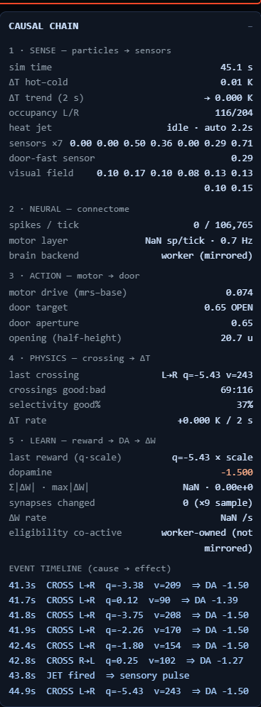
How many time fly efefcinclty work as demon incident or recoding; efficiencies of fly neural network vs Demon in Experiment of Jet expedient in interactive lab test

Brain firing in each case (in Skelton) in each case
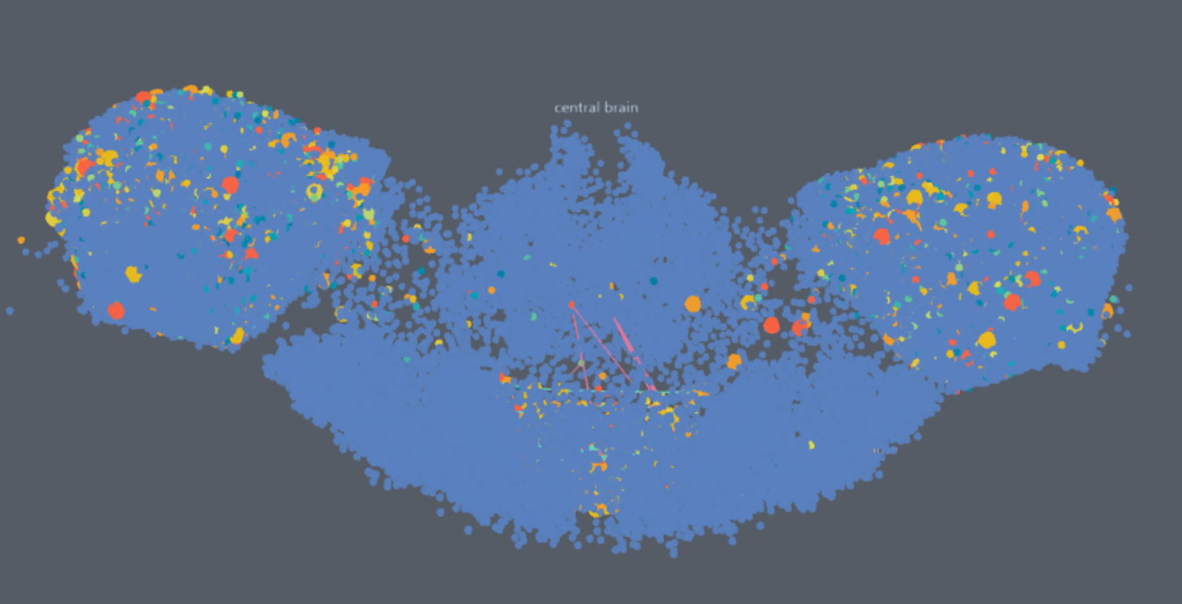 | 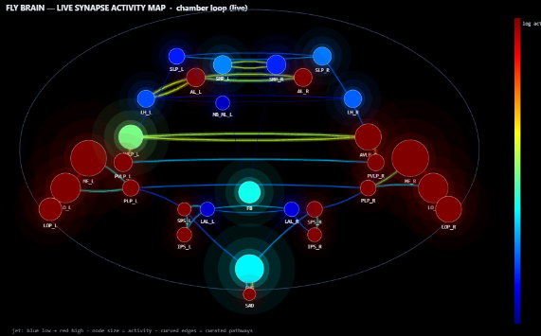
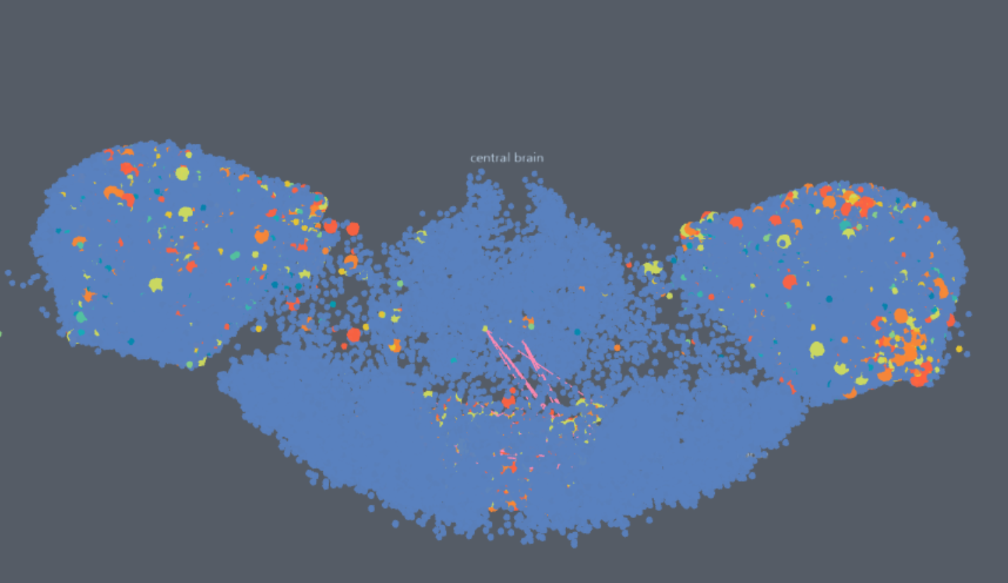 | 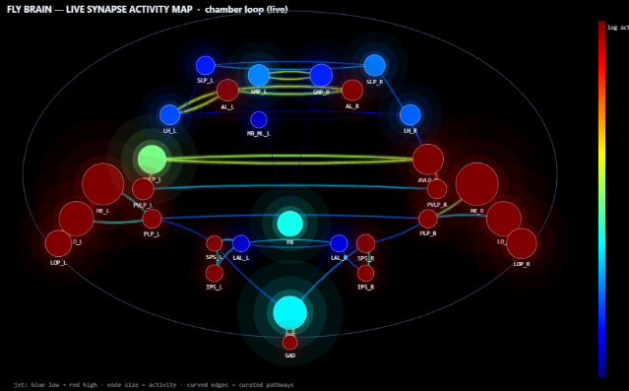

Record: Chemical change and fly other changes as map for 1 min each case

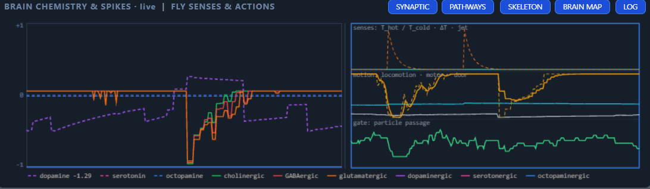
………………………………………………………………………………………………………………………..
Paper guidelines:
Nature: Initial submission
Submissions for Articles, Reviews and Perspectives, and Matters Arising must be submitted via our online submission system. Please follow these guidelines to ensure that your submission proceeds smoothly.
If your manuscript and figures are ready to submit according to the manuscript formatting guidelines and requirements below, please proceed directly to the online submission system.
Brief guide for submission to Nature
This guide outlines key points for preparing primary research manuscripts for submission to Nature.
The corresponding author should be familiar with the Nature journals’ editorial policies and is solely responsible for communicating with the journal and managing communication between coauthors. Before submission, the corresponding author ensures that all authors are included in the author list and agree with its order, and that they are aware the manuscript is to be submitted. For more information on editorial and authorship policies, please review our Guide to Authors.
Cover letter
Although optional, the cover letter is an excellent opportunity to briefly discuss the importance of the submitted work and why it is appropriate for the journal. Please avoid repeating information that is already present in the abstract and introduction. The cover letter is not shared with the referees, and should be used to provide confidential information such as conflicts of interest and to declare any related work that is in press or submitted elsewhere.
Main manuscript
The Nature journals are flexible with regard to the format of initial submissions. Within reason, style and length will not influence consideration of a manuscript. If revisions are requested, the editor will provide detailed formatting instructions at that time.
To facilitate the review process however, we strongly encourage you to incorporate the manuscript text and figures into a single PDF or Microsoft Word file. Suitably high resolution figures may be inserted within the text at appropriate positions or grouped at the end. Each figure legend should be presented on the same page as its figure. The reference list should include article titles. If providing a PDF, please number all lines. The submission system will number all lines in a Word document for you. We accept LaTeX files at the acceptance stage, but before that time please supply PDFs.
Title.Titles must fit on two lines in print (75 characters including spaces) and should avoid technical terms, abbreviations and active verbs.
Authors. Corresponding author(s) should be identified with an asterisk. Large Language Models (LLMs), such as ChatGPT, do not currently satisfy our authorship criteria. Notably an attribution of authorship carries with it accountability for the work, which cannot be effectively applied to LLMs. Use of an LLM should be properly documented in the Methods section (and if a Methods section is not available, in a suitable alternative part) of the manuscript.
Abstract. Provide a general introduction to the topic and a brief non-technical summary of your main results and their implication.
Text length and formatting. Attention to the following details can help expedite publication if we invite a revision after external review.
A fully referenced ~200 word summary paragraph; main text of 2,500 words and 4 modest display items (figures, tables) for a typical 6 page article and 4300 words and 5-6 modest display items for a typical 8 page article; as a guideline up to 50 references if needed and within the allocated page budget. Sections can be separated with subheadings to aid navigation.
Please consult Nature's content types for final length and formatting requirements of other article types.
Methods. The Methods section appears in most online original research articles and should contain all elements necessary for interpretation and replication of the results. Methods should be written as concisely as possible and typically do not exceed 3,000 words but may be longer if necessary. Methods-only references do not count against your reference limit. We encourage you to deposit any step-by-step protocols used in your study in the open resource protocols.io. Protocols that are deposited should be mentioned in the Methods section and added to the reference list.
References. These may only contain citations and should list only one publication with each number. Include the title of the cited article or dataset.
Acknowledgements (optional). Keep acknowledgements brief and do not include thanks to anonymous referees or editors, or effusive comments.
Funding. If the work in the paper is within scope of a grant and arose directly from a specific grant, funding should be declared in a separate funding statement.
Author contributions. You must include a statement that specifies the individual contributions of each co-author. For example: "A.P.M. ‘contributed’ Y and Z; B.T.R. ‘contributed’ Y,” etc. See our authorship policies for more details.
Competing interests. Submission of a competing interests statement is required for all content of the journal.
Materials & Correspondence. Indicate the author to whom correspondence and material requests should be addressed.
Tables. Each table should be accompanied by a short title sentence describing what the table shows. Further details can be included as footnotes to the table.
Figures
High-resolution image files are not required at initial submission, but please ensure images are of sufficient resolution for referees to properly assess the data. We prefer the figures to be incorporated with the manuscript text into a single Word doc or PDF at initial submission, but if necessary, supply separate image files or deposit image data in a suitable repository (e.g. figshare) for this purpose.
Should your manuscript be accepted, you will receive more extensive instructions for final submission of display items. However, some guidelines for final figure preparation are included below and here if you wish to minimize later revisions and possible delays.
- Provide images in RGB color and at 300 dpi or higher resolution.
- Use the same typeface (Arial or Helvetica) for all figures. Use symbol font for Greek letters.
- Use distinct colors with comparable visibility and avoid the use of red and green for contrast. Recoloring primary data, such as fluorescence images, to color-safe combinations such as green and magenta or other accessible color palettes is strongly encouraged. Use of the rainbow color scale should be avoided.
- Figures are best prepared at a width of 90 mm (single column) and 180 mm (double column) with a maximum height of 170mm.. At this size, the font size should be 5-7pt.
- We require vector files with editable layers. Acceptable formats are: .ai, .eps, .pdf, .ps, .svg for fully editable vector-based art; layered .psd or .tif for editable layered art; .psd, .tif, .png or .jpg for bitmap images; .ppt if fully editable and without styling effects; ChemDraw (.cdx) for chemical structures. A guide to preparing final figures is available here: Figure style guide.
- Please refer to the Nature Research chemical structures style guide for formatting of chemical structures.
Figure legends of <250 words each should begin with a brief title sentence for the whole figure and continue with a short statement of what is depicted in the figure, not the results (or data) of the experiment or the methods used. Legends should be detailed enough so that each figure and caption can, as far as possible, be understood in isolation from the main text.
Statistical information
Comprehensive information on the statistical analyses used must be included in the paper. The Methods must include a statistics section where you describe the statistical tests used and whether they were one- or two-tailed. Please ensure that the error bars are defined throughout the figures. For all statistics (including error bars), provide the EXACT n values used to calculate the statistics (reporting individual values rather than a range if n varied among experiments). For representative results, report the number of times that the measurements were repeated. Where relevant, provide exact values for both significant and non-significant P values. For ANOVAs, provide F values and degrees of freedom. For t-tests, provide t-values and degrees of freedom. Please specifically define the replicates.
Extended data
To improve its readability and navigability online, all data integral to the work being described should be included in up to ten multi-panel Extended Data display items similar to regular printed figures and tables. These will not appear in print but are included in the online versions of the published article. If the main finding includes a complex process we encourage the inclusion of a schematic to aid readers unfamiliar with the topic. For initial submission you may include Extended Data items as regular display items in the body of the manuscript or as Supplementary Information. But if accepted for publication, all Extended Data will need to be properly formatted.
Compound numbering
All individual inorganic and organic chemical compounds should be identified by bold numerals (1, 2, 3, etc.), including those that are only mentioned in the manuscript or supplementary information, independent of whether they were utilized in the reported experiments. Standard buffers, reagents and solvents should not be numbered. Please number compounds in order of their appearance in the main text. Alphanumeric numbering can also be used, but try to be logical, for example, starting materials called 1a, 1b, 1c... give products called 2a, 2b, 2c... and so on.
Supplementary information
This should be limited to material that is essential background (for example, large data sets and calculations), but which is too large, impractical or specialized to justify inclusion in the printed version of the article. Any figures or small tables should ideally be supplied as Extended Data, not Supplementary Information.
Data availability
Please provide a Data Availability statement in the Methods section under “Data Availability”; detailed guidance can be found in our data availability and data citations policy. Certain data types must be deposited in an appropriate public structured data depository (details are available here), and the accession number(s) provided in the manuscript. Full access is required at publication. Should full access to data be required for peer review, authors must provide it.
We encourage provision of other source data in unstructured public depositories such as Dryad or figshare, or as supplementary information. To maximize data reuse, we encourage publication of detailed descriptions of datasets in Scientific Data.
Crystallographic data
Manuscripts reporting new crystallographic structures of small molecules must be accompanied by a standard .cif file. A structural figure with probability ellipsoids should be included in the main supplementary information file. The structure factors for each structure should also be submitted, preferably embedded in the main .cif file, although they may be provided as a separate .hkl and/or .fcf file. Use of the 2014 version of the program SHELXL, which embeds the structure factors information in the main .cif file, is encouraged. The structure factors and structural output must be checked using IUCr's CheckCIF routine and a PDF copy of the output supplied, explaining any A- or B-level alerts.
Computer code
Any previously unreported custom computer code used to generate results reported in the manuscript and that are central to the main claims must be made available to editors and referees upon request. Any practical issues preventing code sharing will be evaluated by the editors who reserve the right to decline the manuscript if important code is unavailable. At publication, Nature journals consider it best practice to release custom computer code in a way that allows readers to repeat the published results.
For all studies using custom code that is deemed central to the conclusions, a statement must be included in the Methods section, under the heading "Code availability", indicating whether and how the code can be accessed, including any restrictions.
Github link will be provided
……………………………………………………………………………………………………………………
Yes. With these columns, I would not treat the dataset as one large table of unrelated variables. For the paper, organize them into scientific groups and analyze combinations that correspond to your causal chain:

environment → fly/connectome → neural activity → motor action → gate → particle outcome → reward/learning

Your columns already contain enough structure to build this analysis.

1. I would divide the dataset into 7 groups
Group Columns Purpose
A. Experimental condition mode, goal, flyRuns, nPart, cool What experiment/condition was run
B. Physical environment jet, jetP, jetAim, noise, doorH, doorT, doorPos Physical conditions and gate
C. Neuromodulation / neural rates rate_ach, rate_gaba, rate_glut, rate_da, rate_ser, rate_oct Neural/chemical state
D. Neural/connectome activity spkN, cg, cb, motor, motorBase Network activity and motor output
E. Learning / plasticity lr, rewScale, expl, dwL1, dwN, dwMax Learning and synaptic change
F. Behaviour / performance loco, ntP, rate_ach, bestDT, epT, flyRuns Fly movement and task performance
G. Named neurons / populations np1_name–np5_name, np1_rate–np5_rate Specific neural populations and their firing rates

There are some columns whose exact meaning cannot be established from the names alone—for example dT, tD, tL, tR, da, ser, oct, cg, cb, ntP, bestDT, and epT. I would not rename or reinterpret them until you check the simulation's variable definitions.

2. The most important combinations for your paper

I would build the paper around relationships, rather than showing every column independently.

Combination 1 — Environment → Fly behaviour

Use:

jetP
jetAim
noise
doorH
doorT
doorPos
↓
loco
flyRuns
epT
bestDT

Scientific question:

How does the physical environment affect fly movement and task performance?

This can become a main Results section.

Combination 2 — Neural activity → Motor action

Use:

spkN
cg
cb
motor
motorBase
↓
loco
doorPos

This is extremely important for your connectome story.

The question becomes:

Does connectome activity correspond to motor output and subsequent behavioural action?

This is much stronger than simply reporting spkN or motor separately.

Combination 3 — Motor action → Gate behaviour

Use:

motor
motorBase
↓
doorT
doorPos
↓
crossing / task outcome

This is the direct fly → gate relationship.

If your dataset contains actual crossing events, include those rather than trying to reconstruct them from doorPos unless necessary.

Combination 4 — Reward → learning

Use:

rewScale
expl
lr
↓
reward / task performance
↓
dwL1
dwN
dwMax

This should be one of the central analyses if your claim is that the network learns.

You want to demonstrate something like:

learning condition
↓
network changes
↓
behaviour changes
↓
task performance changes

But do not claim this relationship until the actual data support it.

3. Dopamine / neuromodulation should be its own analysis

You have:

rate_da
rate_ser
rate_oct
rate_ach
rate_gaba
rate_glut

I would not simply put all six into one graph.

Separate them conceptually:

Dopamine
rate_da
↓
reward
↓
dwL1 / dwN / dwMax
↓
motor / behaviour

This is especially important because your experimental concept explicitly involves reward and dopamine.

Other neuromodulators
rate_ser
rate_oct
rate_ach

These can be treated as additional neural-state variables.

Neurotransmission
rate_gaba
rate_glut

These can help characterize the network state.

4. Named neuron populations should NOT be mixed into the main physical analysis

You have:

np1_name np1_rate
np2_name np2_rate
np3_name np3_rate
np4_name np4_rate
np5_name np5_rate

These are very useful, but I would make them a neural mechanism analysis.

For example:

CONDITION
↓
┌────────────────┐
│ Neural network │
└────────────────┘
↓ ↓ ↓ ↓ ↓
NP1 NP2 NP3 NP4 NP5
↓ ↓ ↓ ↓ ↓
firing rates
↓
motor
↓
gate

This could become a figure showing how neural populations change between experimental conditions.

5. The paper should have a "causal core"

I would organize your major analyses around this:

PHYSICAL ENVIRONMENT
┌─────────────────────┐
│ jetP / jetAim/noise │
│ doorH / doorT │
└──────────┬──────────┘
↓
FLY OBSERVATION
↓
CONNECTOME ACTIVITY
spkN / cg / cb
↓
MOTOR OUTPUT
motor / motorBase
↓
GATE ACTION
doorT / doorPos
↓
BEHAVIOUR
loco / flyRuns
↓
REWARD
↓
NEUROMODULATION
rate_da / rate_ser...
↓
PLASTICITY
dwL1 / dwN / dwMax
↓
FUTURE BEHAVIOUR

That is much closer to the scientific story you are trying to demonstrate than simply making 40 separate plots.

6. What should be combined vs separated?
Combine

These make good paired/combined analyses:

jetP + jetAim + noise
→ environmental condition

doorT + doorPos + motor
→ motor/gate interaction

spkN + cg + cb + motor
→ neural activity → motor output

lr + expl + rewScale + dwL1 + dwN + dwMax
→ learning/plasticity

rate_da + reward + dw*
→ dopamine/reward/plasticity

np1_rate ... np5_rate + motor
→ population activity → motor output

loco + flyRuns + epT + bestDT
→ behavioural performance

Keep separate

I would keep these separate from the mechanistic analyses:

Experimental identifiers

mode
goal

Population identifiers

np1_name ... np5_name

Physical particle count

nPart

Temperature/environment condition

cool

These are better used as conditions, grouping variables, or metadata, rather than treating them as neural variables.

7. For the paper, I would make 5 major figures from this dataset
Figure 1 — Experimental system
Drosophila connectome
↓
neural network
↓
motor
↓
gate
↓
particle environment

Use the apparatus and architecture.

Figure 2 — Neural control
spkN
cg / cb
↓
motor
↓
doorT / doorPos

This establishes the connectome-to-action relationship.

Figure 3 — Learning
learning rate
exploration
reward scale
↓
dopamine
↓
ΔW
↓
behaviour/performance

Variables:

lr, expl, rewScale, rate_da, dwL1, dwN, dwMax.

Figure 4 — Maxwell-demon behaviour
jetP / jetAim / noise
↓
fly movement
↓
gate crossings
↓
hot/cold outcome

This should be one of your key experimental figures.

Figure 5 — Neural mechanism

Use:

np1_rate
np2_rate
np3_rate
np4_rate
np5_rate

against:

motor
doorPos
reward

to investigate which recorded populations are associated with the behaviour.

8. Most important point: don't correlate everything with everything

With this dataset it would be tempting to generate a giant correlation matrix.

I would not make that the main analysis.

Instead, test specific hypotheses:

H1

Neural activity is associated with motor output.

spkN / cg / cb → motor

H2

Motor output is associated with gate action.

motor → doorT / doorPos

H3

Gate action is associated with behavioural outcome.

door → loco / crossings / flyRuns

H4

Reward/dopamine is associated with plasticity.

reward / rate_da → dwL1 / dwN / dwMax

H5

Learning is associated with improved task performance.

training/episode → performance

These five relationships would give your paper a much stronger scientific structure.

One thing I need before going further

Your column names strongly suggest that this dataset can support the paper, but the abbreviations need to be mapped to their actual definitions.

For example, I don't want to guess whether:

dT
Tl
Tr
da
ser
oct
cg
cb
ntP
bestDT
epT
…………………………………………………………………………………………………………………..

